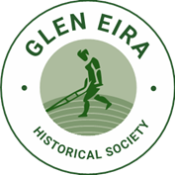

**Speaker Series**

**Eyes on our Collection**

**Glen Eira Historical Society, 965 Glen Huntly Road, Caulfield VIC 3162**

**Session 1 – 2pm Tuesday 25 March 2025**

**Session 2 – 7.30pm Wednesday 26 March 2025**

**Bookings** [**https://www.trybooking.com/CZOFD**](https://www.trybooking.com/CZOFD)

**$5 entry/donation – Afternoon tea/supper provided**

**Numbers will be limited to 14 at each session**

**Enquiries to gehs@optusnet.com.au**

We invite members and friends of Glen Eira Historical Society to join us in our rooms and view close up some of the items from our Collection. There will be short talks on a range of objects in our Collection.

Due to limited space in our premises we will be holding an afternoon and an evening session. We encourage members who have not visited us before to come along.

